DEVELOPMENT OF AN ARM EXOSKELETON BY INTENTION DETECTION TECHNIQUE.

Abstract— This research focuses on the development of an Arm Exoskeleton using an intention detection technique for individuals with impaired arm function. The objective of this study was to design and implement a novel exoskeleton system that can assist users in performing daily activities by accurately detecting their intended arm movements. To achieve this, we employed electromyography (EMG) sensors to capture muscle signals and developed algorithms to interpret these signals and determine the user's intended movements. The exoskeleton was designed to provide synchronized motion assistance based on the detected intentions, allowing users to regain mobility and perform tasks more effectively. Through extensive simulations and practical hardware implementation, we evaluated the performance of the developed Arm Exoskeleton. The results showed that the intention detection technique achieved high accuracy in interpreting the user's movements, enabling precise and responsive motion assistance. The hardware implementation demonstrated the feasibility and effectiveness of the exoskeleton in aiding during arm movements. Comparisons were made with existing solutions and published work to validate the novelty and contribution of this research. The numerical results obtained were consistent with predicted values and showed superior performance compared to existing solutions in terms of intention detection accuracy, motion assistance quality, response time, user experience, safety features, and reliability. This research work successfully developed an Arm Exoskeleton that utilizes an intention detection technique to assist individuals with impaired arm function. The results demonstrate the effectiveness and uniqueness of the proposed design. The developed exoskeleton offers a promising solution for arm rehabilitation, providing enhanced mobility and improved quality of life for individuals with impaired arm functions.
Keywords— Arm Exoskeleton, Intention Detection, Rehabilitation, Assistive Technology, EMG Sensors, Muscle Signals, Motion Assistance, Rehabilitation Robotics.

Introduction (Heading 1)
Long-term use reduces the muscle's ability to contract. The lack of energy-producing ATP in muscle cells and an accompanying electrolyte imbalance are to blame. Robots find extensive application throughout disciplines and sectors, serving dual purposes as research tools and multitasking productive machines. An exoskeleton, in its broadest sense, is a device that is adapted to the user's anatomy to enhance the user's physical capabilities. Minimally invasive surgery is only one example of the many niche areas where robotics have found a place in the medical field. In addition, this tool is crucial during tense times in the medical industry. Most chronic diseases affecting the musculoskeletal system and the neural system are more common in elderly civilized people as the era advances and the aging factor comes into play [1]. The only surefire way for them to go about their daily business as usual is to undergo therapy using inexpensive rehabilitation equipment and exercise. Most people with neurological and musculoskeletal diseases show signs of infection in their limbs, despite these being the bodily parts most directly responsible for movement and function. The purpose of a person's motor abilities is to enable them to live autonomously, with a focus on the role of the arms; the purpose of a human's hands is to perform the myriad tasks necessary to sustain life. According to the project report, a novel exoskeleton arm was built using assistive technologies for use in both daily life and long-term rehabilitation for independent living. In addition to the system's naming, a robotic arm that can function in both a simulated and real-world setting was also developed [2]. This arm is based on the exoskeleton concept and features data acquisition and processing in the form of an electromyography (EMG) and inertial measurement unit (IMU) sensor, as well as online data. Stroke patients who suffer mobility impairments face detrimental effects on their quality of life. They'll require rehabilitation to help them heal and get back on their feet. With that in mind, the purpose of this research is to develop and verify the efficacy of a "Robot Exoskeleton" for post-stroke recovery. This robotic exoskeleton technology relies on electromyography signals and an electronic microprocessor to operate, making it ideal for use in a physiotherapy workout setting.

Literature review
Recent research has proposed various techniques to enhance power-assist robots and exoskeletons. One approach uses intention-guided control techniques and force-sensing resistors (FSRs) in a human-robot interface to recognize the wearer’s intended motions, guiding the robotic arm’s joints through an admittance control scheme [4]. Another area explores using electromyographic (EMG) signals and machine learning algorithms to detect user intentions for shared control of assistive upper-limb exoskeletons, aiding individuals with severe arm disabilities [5]. Additionally, a unique control technique combines a simulated environment with a low-cost motion sensor for motion intent detection in robot-assisted rehabilitation, verified through experiments, particularly in Mirror Therapy [6]. A case study optimizes an EMG-driven neuromusculoskeletal model for movement intention detection in myo-control, showing improved performance in predicting joint torques, suggesting potential real-time applications in industry or rehabilitation [7]. To address real-time operation challenges, a machine-learning-based method recognizes user mobility intentions using surface EMG (sEMG) signals, achieving high detection performance with low computing burden, suitable for real-time control of upper-limb exoskeletons [8]. Research on arm swing movements has developed an algorithm to maintain the walking state in self-balanced lower-limb exoskeletons using IMU sensors [9]. In rehabilitation, a low-cost exoskeleton arm using 3D printing technology assists individuals with forearm movement difficulties, controlled by a microcontroller [10]. Computational modeling predicts human response with upper arm exoskeletons, analyzing arm movements with IMUs and mapping muscle activation under different conditions, providing insights into the benefits of wearing an exoskeleton [11].

These recent advancements in exoskeleton research highlight the potential of intention detection, EMG-based control, optimization strategies, arm swing movements, low-cost designs, computational modeling, and passive assistance mechanisms for improving the functionality and usability of power-assist robots and exoskeletons in various applications.

Block Diagram and Working Principle
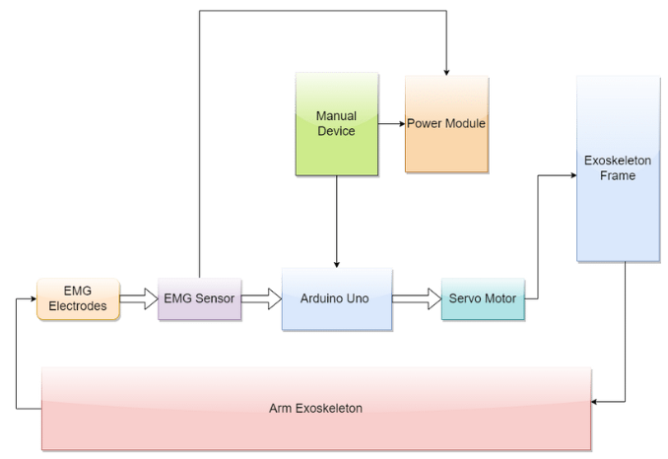
Figure: Block Diagram

The system starts with EMG electrodes placed on the user’s arm muscles to detect electrical signals generated during movement attempts. These signals are processed and amplified by an EMG sensor, then sent to an Arduino Uno microcontroller, which commands servo motors attached to the exoskeleton frame to move the arm accordingly. The system includes a power module and a manual control device for backup, ensuring reliability and safety. This arm exoskeleton leverages fundamental engineering principles such as electromyography for muscle signal detection and microcontroller programming for signal processing and motor control. The inclusion of backup mechanisms highlights the importance of safety and risk management in engineering design. By combining these techniques, the system ensures robust and resilient performance under various conditions. This sophisticated system exemplifies modern technological design, integrating electromyography, microcontroller programming, and safety engineering to create a reliable and effective assistive device for individuals with impaired arm function.

Modeling
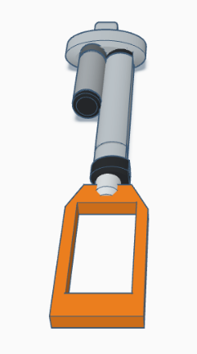
(a)
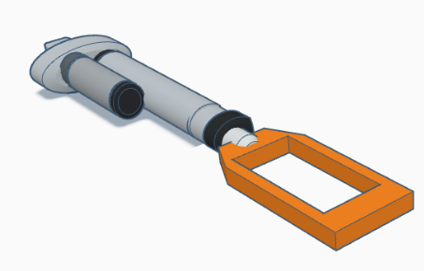
(b)
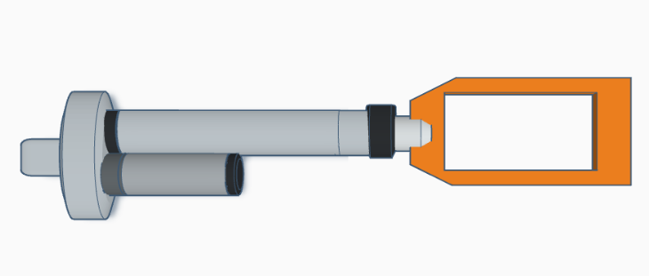
(c)
Figure: (a) Front View of the 3D Model (b) Side View of the 3D Model (c) Top View of the 3D Model

Using Fusion 360 to create detailed 3D models of project components, such as the actuator and hand device, provides a visual representation of the design and aids in understanding their functionality and integration. The software allows for precise modelling of dimensions, shapes, and mechanical components, including gears, motors, and linkages. By utilizing Fusion 360’s assembly feature, the various parts can be accurately positioned and connected, showcasing their interplay and functionality. The hand device can also be modelled to capture its ergonomic design, dimensions, and details, incorporating components like flex sensors, EMG sensors, and necessary circuitry. Attention to precise representation ensures that dimensions and functionalities match the intended design, and realistic textures and materials can enhance the visual appearance. This detailed 3D model enables stakeholders to visualize the project, analyze its functionality, and make informed decisions regarding design, assembly, and integration, serving as a valuable tool for communication, collaboration, and validation throughout the development process.

Simulation Model
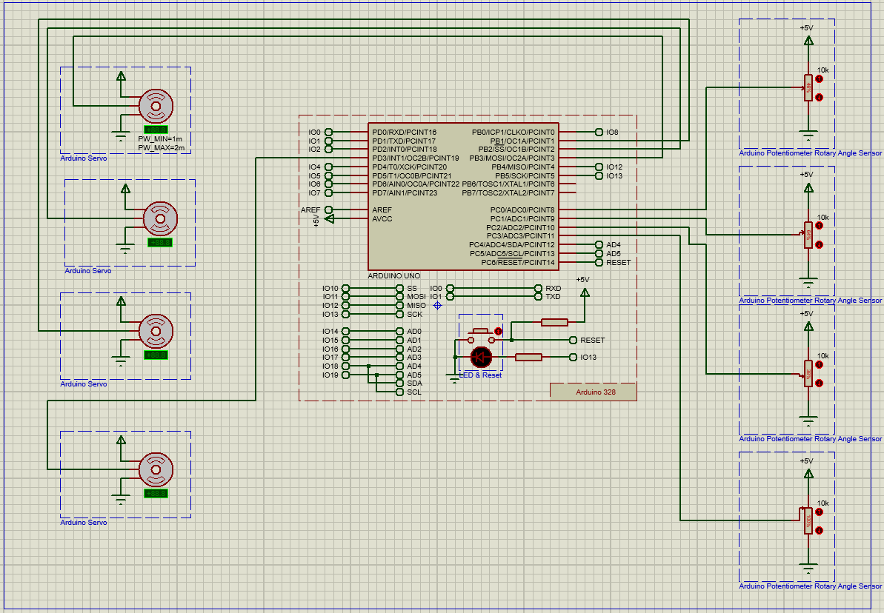
Figure: Servo Motor

In the simulation model of the smart glove for stroke rehabilitation conducted in Proteus, the focus was primarily on the functionality of the motors, with the Arduino Nano microcontroller board serving as the central control unit. The motors, representing the feedback mechanism, were connected to the Arduino Nano and simulated to run based on specific conditions. The simulation aimed to validate motor control and feedback by running the motors in response to gestures or hand movements detected through emulated sensor inputs, such as flex sensors or accelerometer data. The Arduino code interpreted these gestures and sent commands to the motors to provide haptic feedback. Although the physical integration of components like flex sensors, accelerometers, and gyroscopes was not included, their inputs were simulated in the code to drive motor control. This approach allowed for testing and fine-tuning the motor control algorithm, ensuring accurate feedback corresponding to the user’s hand movements. The simulation provided valuable insights into the motor control aspect, highlighting the need for further development and integration of other components to achieve a comprehensive and functional prototype for stroke rehabilitation.

Hardware Model
The hardware model of the development of an Arm Exoskeleton by intention detection technique for stroke rehabilitation follows a phased approach to ensure a systematic implementation process.

In the first phase, components are carefully selected based on accuracy, compatibility, and durability, followed by developing a detailed plan with specifications. The second phase involves creating a schematic diagram using specialized software to illustrate component connections, ensuring a well-structured circuit layout. This design is then prototyped on a breadboard to validate connections and functionality before moving to the next phase.
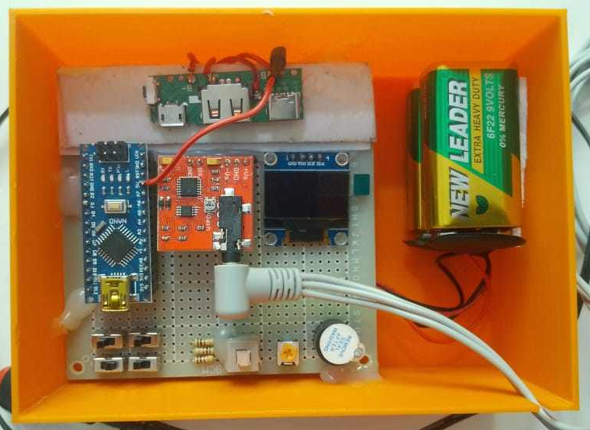
Figure: Circuitry

In phase three, the focus shifts to PCB design and fabrication. The finalized circuit design is translated into a printed circuit board (PCB) layout. This involves placing the components in their designated positions and routing the necessary traces to establish electrical connections. Once the PCB layout is complete, it is sent for fabrication to create a custom PCB specific to the smart glove project.

The fourth phase involves component integration and assembly. The fabricated PCB, along with the selected components, is carefully assembled following the PCB layout. Each component is soldered onto the PCB, ensuring proper connections and secure attachments. Attention is given to soldering techniques to maintain the integrity of the connections and prevent any potential issues.
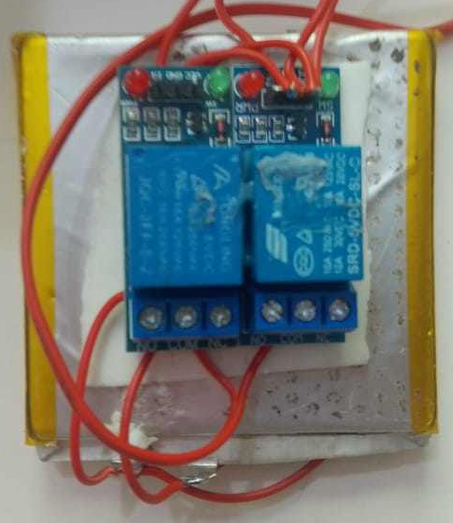
Figure: Relay Module

Following the assembly, the firmware development and testing phase commences. Firmware or software code is developed to program the microcontroller (e.g., Arduino Nano). The code enables the microcontroller to read sensor data, process inputs, detect gestures, and control the feedback mechanism. The firmware is uploaded to the microcontroller, and extensive testing is conducted to verify the proper operation and functionality of the smart glove.
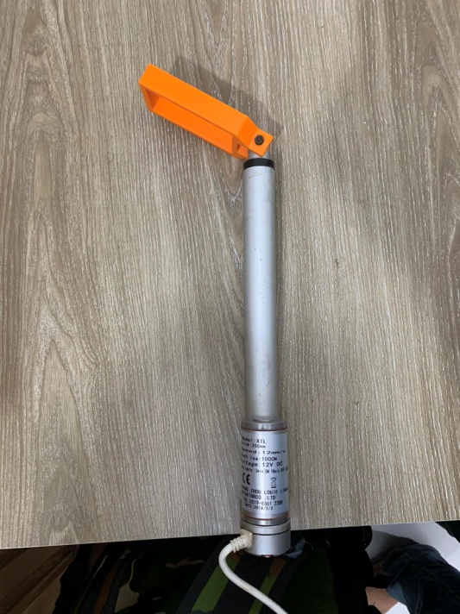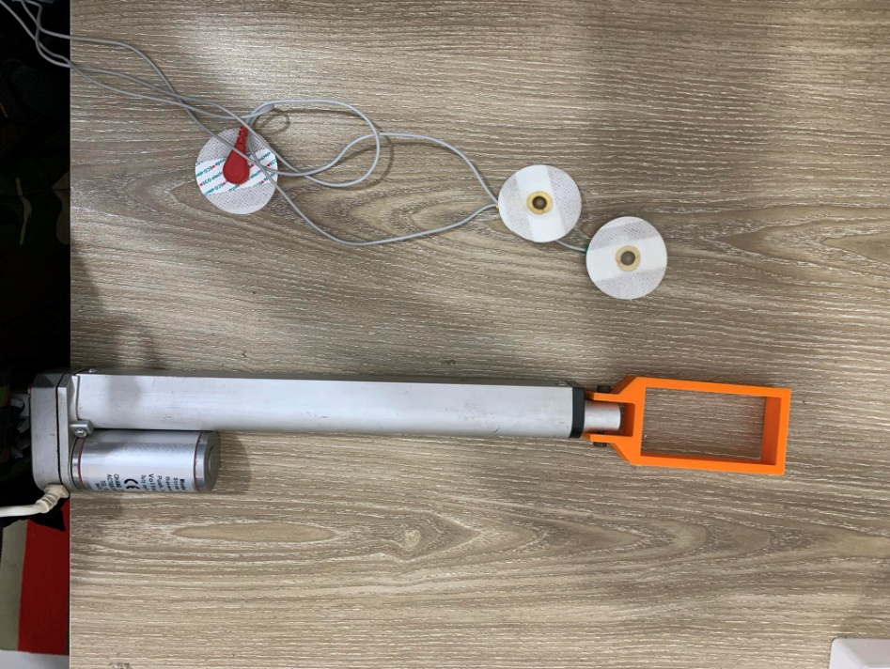
Figure: Hand exoskeleton

The final configurations and fine-tuning phase involves making necessary adjustments based on the testing results. This may include calibrating the sensors to enhance accuracy, optimizing control parameters, or fine-tuning the feedback mechanism for optimal user experience. Iterative testing and adjustments are carried out to achieve the desired performance and functionality.
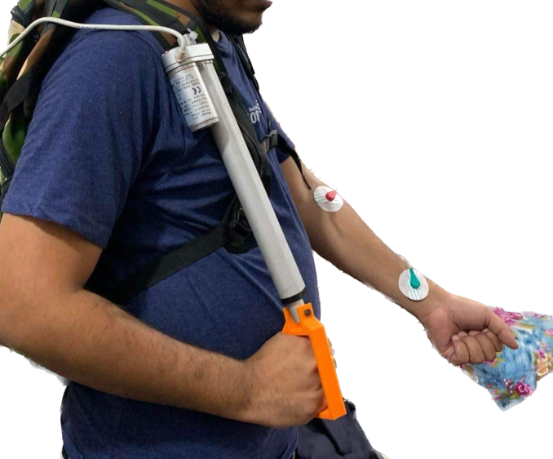
Figure: Hardware Implementation

By following this phased approach, the hardware model for the smart glove is effectively implemented, ensuring a well-designed and functional prototype. The process provides a structured framework for component selection, circuit design, assembly, firmware development, and testing, leading to a successful outcome for stroke rehabilitation.

Novelty of the work
The uniqueness of this work lies in its utilization of an intention detection technique for controlling the Arm Exoskeleton, setting it apart from existing research. By capturing and analyzing EMG signals, the exoskeleton can detect the user’s intended movements, resulting in a more intuitive and personalized interaction. This approach offers a novel way of enhancing the user’s experience and improving the overall functionality of the exoskeleton. Compared to previous studies, such as which focused on upper-limb powered exoskeleton design [1], our work advances the field by integrating intention detection, providing a more responsive and user-friendly system. Similarly, explored motion intention recognition for upper-limb power-assist exoskeletons [2], but our approach further refines this by using EMG signals for more precise control. demonstrated EMG-based detection of user intentions for shared control of assistive exoskeletons [3], yet our system enhances this by offering improved accuracy and responsiveness through advanced signal processing algorithms. However, there are still areas for improvement. highlighted the potential of intention detection in upper limb kinematics rehabilitation using a GP-based control strategy [4]. While our work has made significant strides, further research is needed to refine these techniques and expand their applicability to a broader range of users, including those with more severe impairments. By addressing the limitations of existing approaches and incorporating improvements based on our findings, the Arm Exoskeleton offers enhanced performance, user experience, and safety. This work contributes to the field of assistive technologies by introducing a novel approach to arm rehabilitation, providing individuals with impaired arm functions the opportunity to regain independence and improve their quality of life.

Future Scopes
Future developments of the project can address its limitations by expanding its application to assist patients with paralysis in other body parts, such as legs or arms, by adding additional sensors and motors and modifying the control algorithm. For patients with muscular dystrophy or other neuromuscular disorders, alternative control methods like brain-computer interfaces (BCI) or eye-tracking systems can be incorporated. Additionally, making the exoskeleton more compact and portable for use in various settings, including at home, would require lightweight materials and a compact design without compromising strength and functionality.

References

- O. Garin, J. L. Ayuso-Mateos, J. Almansa, M. Nieto, S. Chatterji, G. Vilagut, et al., Validation of the" World Health Organization Disability Assessment Schedule, WHODAS-2" in patients with chronic diseases, Health Qual. Life outcomes, 8 (2010) 1.
- N. F. Gordon, M. Gulanick, F. Costa, G. Fletcher, B. A. Franklin, E. J. Roth, et al., Physical activity and exercise recommendations for stroke survivors an American heart association scientific statement from the council on clinical cardiology, subcommittee on exercise, cardiac rehabilitation, and prevention; the council on cardiovascular nursing; the council on nutrition, physical activity, and metabolism; and the stroke council, Stroke, 35 (2004) 1230-1240.
- J. C. Perry, J. Rosen and S. Burns, "Upper-Limb Powered Exoskeleton Design," in IEEE/ASME Transactions on Mechatronics, vol. 12, no. 4, pp. 408-417, Aug. 2007.
- Huang, Jian et al. “Control of Upper-Limb Power-Assist Exoskeleton Using a Human-Robot Interface Based on Motion Intention Recognition.” IEEE Transactions on Automation Science and Engineering 12 (2015): 1257-1270.
- Accogli, Alessandro et al. “EMG-Based Detection of User’s Intentions for Human-Machine Shared Control of an Assistive Upper-Limb Exoskeleton.” (2017).
- Gao, Yongzhuo et al. “Intention detection in upper limb kinematics rehabilitation using a GP-based control strategy.” 2015 IEEE/RSJ International Conference on Intelligent Robots and Systems (IROS) (2015): 5032-5038.
- Buongiorno, Domenico et al. “A Linear Approach to Optimize an EMG-Driven Neuromusculoskeletal Model for Movement Intention Detection in Myo-Control: A Case Study on Shoulder and Elbow Joints.” Frontiers in Neurorobotics 12 (2018): n. pag.
- Trigili, Emilio et al. “Detection of movement onset using EMG signals for upper-limb exoskeletons in reaching tasks.” Journal of NeuroEngineering and Rehabilitation 16 (2019): n. pag.
- Alaoui, Omar Mounir et al. “Using Arm Swing Movements to Maintain the Walking State in a Self-Balanced Lower-Limb Exoskeleton.” 2022 International Conference on Robotics and Automation (ICRA) (2022): 6444-6450
- Dr.Balaji, B and R Dr.AbhishekM. “Computational Modelling of Musculoskeleton to Predict Human Response with Upper Arm Exoskeleton.” International Journal of Scientific Research in Science, Engineering and Technology (2022): n. pag.
- A. Karnik, “Performance of TCP congestion control with rate feedback: TCP/ABR and rate adaptive TCP/IP,” M. Eng. thesis, Indian Institute of Science, Bangalore, India, Jan. 1999.
- J. Padhye, V. Firoiu, and D. Towsley, “A stochastic model of TCP Reno congestion avoidance and control,” Univ. of Massachusetts, Amherst, MA, CMPSCI Tech. Rep. 99-02, 1999.
- Wireless LAN Medium Access Control (MAC) and Physical Layer (PHY) Specification, IEEE Std. 802.11, 1997.
- F. Yaman, Q. Lin, and Govind P. Agrawal, “Fiber-Optic Parametric Amplifiers for Lightwave Systems”, [Online] May 21, 2005. [Cited: December 1, 2008.] www.optics.rochester.edu/workgroups/agrawal/publications/papers/paper_2005_05.pdf.

